|  |
| --- |
|  |

|  |
| --- |
| **The time Grinder** |
| Gadget Project |
|  |
|  |
|  |
| **Natacha Audy and Séverine André** |
|  |
| **10/04/2012** |
|  |

Contents

Contents 1

I Description 2

II Biographies of the inventors 3

III Technical operating 5

IV Instruction manual 6

V Technical specification 7

VI Questions and answers 8

VII Things and time 9

VIII Consumer information 9

I Description

The time grinder is a machine that allows you to store time to use later. Instead of wasting your time when you are doing nothing, you can store it onto the time grinder bottle. Later, as you need more time to do something or just want to relax, you can use the time store by drinking it.

It’s a gadget for adults over 18 only.

Store your time

* At the bus stop:

You lose your time by waiting the bus every morning and evening. Store your time thanks to the time grinder and it is as if the bus was here immediately. In this way, you will collect time every day.

* Standing in line at the supermarket

You hate to wait in line and there are five people behind you. Thankfully you have a time grinder, so it is your turn to pay at the checkout. You have gained a few minutes.

* Time to kill

Nothing to do this week but you know that the next will be charged. Store this time instead of wasting it on the internet.

* It’s raining

Keep this time for later instead of watching TV

Use your time

* The week end

Soon the end of the weekend... Your time grinder will allow you to don’t think immediately to Monday.

* You are late?

Two minutes earlier and you would have been on time! With your time grinder you have time to walk quietly to your workplace.

* Housework to do

You push your housework back for too long? The best way to don’t take on your spare time is the Time Grinder!

* Lack of sleep

Who has never dreamed of one or two hours more sleep…

* An omission

Forgotten to do something? You have time in your pocket!

II Biographies of the inventors

Natacha Audy’s biography

Natacha was born on August, 20th 1990 in Bergerac, in the Perigord region.

**Since the age of ten years old:** She loved watching the 1985 American science-fiction trilogy “Back to the future”. She has seen these films not less than twenty times and knows by heart the stories. What she liked about it is the gadget to back to the future and which can play with the time. Knowing well that this gadget is unrealistic, she has always dreamt of creating a machine which could modify the time in order to ameliorate our life.

**In 2002:** Her father died of the Lyme illness making her mother the only one to take care of her five brothers and sisters as the family firm too. She helped her mother working after the school and seeing to her young brothers and sisters. They had not enough time for them to spend good moments in family causing their relation to deteriorate.

**In August 2003:** She was lucky to be able to go to the beach thanks to her best friend. It was the first time that she went to see the Atlantic. Arrived over there, she fell in love with sand. She had assimilated it to the time which threads between hands; this time so beautiful but so imperceptible.

**The August, 20th 2004:** A mother’s friend offered her a book about astronomy. She could learn the bases of this science and she particularly learnt one thing which fascinated her: the stars in the sky contemplated during beautiful summer’s nights, as well as the planets, which we observe thanks to telescopes, are saw by us in past. Indeed, they are so far that the light takes time to reach our eyes. This day she understood that we could maybe one day control the time.

**In May 2005:** She wasn’t a good student and will pass the certificate of general education in two months but she decided to continue her studies to work sciences and to learn physics.

**In July 2009:** She obtained the A-level science-oriented and chose to postulate in electronics engineering school to learn how to conceive machines. This school being situated far from her family, she had to make sacrifices to be able to reach her dream and not to be in the same financial situation than her mother. The following comeback, she began to study there.

**Since 2009:** And for all holidays, she returned to home in the Perigord by train. But every time, she asked herself if she was not a cursed person because her train was always late or had an accident. She lost much time and as she had little patience, it irritated her. In higher education school, she had a lot of homework and could not allow it to waste time to wait on a platform. She even managed to be disappointed by her marks thinking she would have been able to make better in spending more time.

**The November, 15th 2012:** The pupils of her promotion were in the doubt of a test for the next day. She had already organized and planned to celebrate her best friend’s birthday. She asked to a friend if he knew for the control and he answered her that he had sent an e-mail to the professor and that it would take place. Relying on her, she chose not to go to the party and to revise as much as possible to have a good mark. The next day, no test took place and moreover her best friend was disappointed, her friend laughed to have believed it. From this moment, she swore to rely less on her friends to lose her precious time to believe people who are not worth it.

Séverine André’s biography

**1991:** Séverine Roxanne André was born on November 15, 1991 at Paris. She is the child of Francis André and Francette Morin, which will got married five years later. She has a big sister named Coralie and a little sister named Cyrielle.

**1991-1997:** She grew up in the Val de Marne, in an apartment building. His parents worked and she spent her holiday at her grandparents’, she was sad not to see them more often.

**1997:** Her little sister was born and they moved to a small house, still in the Val de Marne.

**1997-2001:** Close to her big sister, they played together and imagined crazy inventions they built with Legos. She began to try all sorts of manual activities and enjoy making things with his hands.

**2001:** Her father, which works at France Telecom, was transferred, making they move house to Locquémeau, a small port in Bretagne. She continued to build things, like a lift on the stairs for her stuffed animals.

**2002-2006:** She was bored at college and counted every second. She would have like time is speeding along and she despaired of wasting her time. She spent her evenings reading fantasy books.

**2006-2009:** The high school didn’t please her either. She started thinking about her future and she felt she wasted time learning things that would perhaps never serve to her.

**2008:** Her big sister decided to leave to Japan for her studies. Séverine stopped sleeping; she wasn’t able to believe she wouldn’t see her sister. Soon she hallucinated, in her delirium she dreamed that her sister came back when she was old, time had passed and she had seen nothing.

**2009-2011:** She passed her bachelor in sciences and registered in BTS optics. She finally found a field she liked and started to be interested in her father's work. He explained her electronics. She read scientific journals that talk about the shape of space, the relativity of time. She kept the contact with her sister.

**2011:** She enrolled in Polytech Orleans. She was 20 and the time seemed more valuable than ever. She had lot of works but still found time for her passions. She met Natacha at the beginning of the year.

**2012:** One weekend she went cycling with Natacha. During a break, lying on the lawn, they talked about their view of time. An idea for an invention began to form.

**2014:** The idea turned into invention. After spending evenings, late nights and weekends on this, their first invention was born. They filed a patent for their time grinder.

III Technical operating

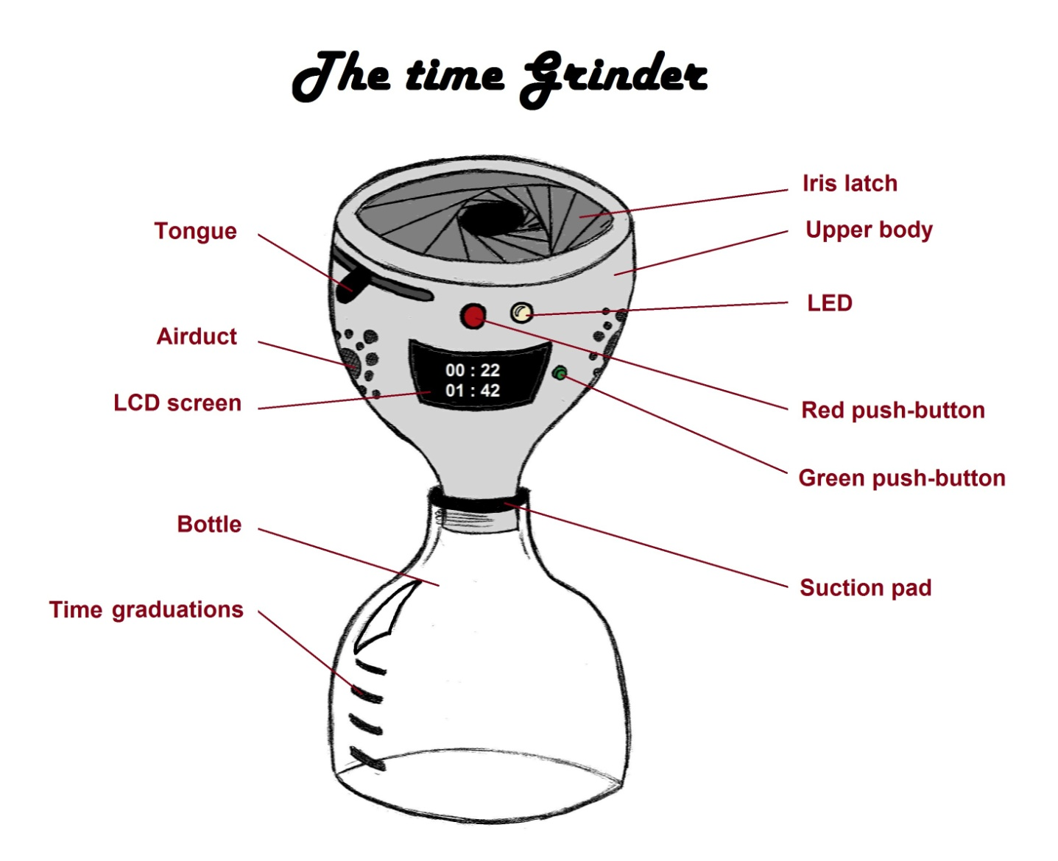

The machine consists of two parts: the upper body which serves to turn the object into got back time and the bottle which recovers this time in the form of liquid. More precisely, it consists of an object scanner, a scrambler, a humidifier, a level sensor, two push-buttons, a LED, a LCD screen, an iris latch and a tie to carry the gadget.

The machine is fed either by a flat battery or by a solar panel depending on the model. After having put an object at the top of the gadget, the user closes the system thanks to a tongue. By pushing on the red button placed next to the iris latch, the tongue is jammed in order to begin the transformation of the object. At first, the machine scans the user’s object thanks to UV and IR radiations and calculates the time which represents the object in connection with his lost time. Once the scan finished, the gained time and the remaining total time are displayed on a LCD screen placed on the side.

The grinding of the object begins: the object is warmed by a heating resistance for facilitating the grinding and then is grinded thanks to turning blades. Then, we get a powder which afterward is turned into a liquid thanks to a moistening system. The ambient humidity is got back by a ventilator. The high temperature alters the humidity in liquid which flows on the internal sides of the gadget. The blades which turn, mixes the water with the powder.

Once the finished mixture, it opens the trapdoor below the body making the liquid free in the lower bottle. A sensor placed in the upper part of gadget detects no substance causing a LED to light indicating the liquid is ready to be used. Another sensor consisting of a transmitter and a receiver detects the level of the liquid in the bottle and allows posting the total time to reuse.

The user can get back the bottle fixed to the upper part of the gadget connected by a screwing and a suction pad creating an internal pressure for that the bottle doesn’t fall unintentionally. Finally, the screen turns off after 30 seconds thanks to a microcontroller. The user can check at any time the reusable time by pressing on a green button.

IV Instruction manual

1. First, open the iris latch on the upper body of the time grinder by sliding the tongue on the side.
2. Put things onto the upper body. The more important those things are for you, the more time you will store.
3. Close the iris latch by sliding the tongue to the other side.
4. Push the red button to trigger the grinder.
5. Once the grinding is complete, the LCD screen switches on and you can see how much time you have gained and what your total time gain is.
6. After 30 seconds, the LCD screen switches off. If you want to switch the screen on again, press the green button next to the LCD screen.
7. After that, a fluid flows onto the graduated bottle. The volume of this fluid is proportional to the time gained.
8. As soon as the all the fluid has flown onto the bottle, the white LED switches on.
9. At this time several options are possible.
   1. The first solution consists in putting again a thing onto the time grinder to gain more time.
   2. The second solution consists in doing nothing. In this case you keep your time for later.
   3. The latest solution consists in drinking the fluid.
10. To drink the fluid, you have to disassemble the two parts of the time grinder. To do that, grab each bodies of the time grinder (the grinder and the bottle) and unscrew.
11. And finally you have just to drink the fluid to use the time you have store. You don’t have to drink all the fluid.
12. Don’t forget to screw back on the two bodies.

V Technical specification

The time grinder is available in five sizes listed as following: 1HTG, 3HTG, 6HTG, 12HTG, 24HTG. The biggest is the 24HTG and the smallest the 1HTG.

The number means how much time the time grinder can store. H is for Hours and TG for Time Grinder. For example, 24HTG means 24 hours’ time grinder, you can store until 24 hours.

Below the product specifications:

|  |  |  |  |  |  |
| --- | --- | --- | --- | --- | --- |
|  | 1HTG | 3HTG | 6HTG | 12HTG | 24HTG |
| Capacity | 1 hour | 3 hours | 6 hours | 12 hours | 24 hours |
| Length | 6cm | 9cm | 20cm | 25cm | 50cm |
| Diameter | 2cm | 6cm | 10cm | 15cm | 30cm |
| Weight (bottle empty) | 10g | 30g | 60g | 120g | 240g |
| Weight (bottle full) | 15g | 45g | 90g | 180g | 720g |
| Average speed | 2s/hour | 2s/hour | 2s/hour | 3s/hour | 4s/hour |
| Price | 22€ | 65€ | 130€ | 250€ | 499.99€ |

Example:

The 6HTG is able to store 6 hours of your time at most. It is 20 cm long and its largest diameter is 10 cm.

Empty bottle, the time grinder weighs 60g and full bottle, it weighs 90g. So this means 6 hours weigh 30g.

Its speed is 2s/hour: the time grinder takes 2 seconds to store 1 hour, you can consider you lose 2 seconds each time you store 1 hour. Another example: if you want to store 6 hours in one time, you will take 6x2=12 seconds on your present time.

The 1HTG is a key chain. The 3HTG fits on your pocket. The 6HTG and the 12HTG fit on your bag. The 24HTG has a strap to be carried everywhere. You also can hook a strap on other products, except on the 1HTG which is too small.

VI Questions and answers

|  |  |
| --- | --- |
| Questions | Answers |
| I can’t open the iris | * Slid the tongue * Wait the white LED switches on |
| I put on the wrong thing | * As long as you haven’t pressed the red button, you can get up your thing |
| The grinder doesn’t work | * Close the iris * Check battery * If the bottle is full you can’t grind things before having a little emptied the bottle * You can’t grind animals |
| Little liquid flows | * The volume of fluid depends on value of the thing you have put on the grinder * you are in an area too dry, the system needs ambient humidity |
| I want to know how much time I have store | * Push the green button near the LCD screen, the time you have store will appear |
| I can’t unscrew the two bodies | * Wait all the fluid flows onto the bottle and the white LED switches on |
| Nothing happen when I drink the fluid | * You haven’t stored enough time to see the difference * For biological reason, time can only be used by the person who has stored it |

VII Things and time

How much time this thing can give me? What should I bring to store 1 hour? The following table gives indications to regulate your time correctly. The more you value your object, the more time you will store.

|  |  |
| --- | --- |
| Things | Time |
| Wastes (leaves, wood, stone, peelings…) | 1min/100g |
| A pencil you like | 10min |
| The cup in which you drink every morning  One of your books or CDs | 30min |
| Your lucky charm | 1h |
| Your favorite t-shirt or shoes | 2h |
| Your last birthday present  A ring, a bracelet | 4h |
| A photo album of your holiday  Your new high tech phone | 6h |
| A childhood memory | 12h |
| The only picture of a departed loved one | 24h |

This table is just as an indication. Again, it depends on the value you place on this object. The more trouble to separate you will have, the more time you will store.

VIII The use risks

A bad utilization of the gadget can cause many risks. This device is not a toy!

* *Drink the temporal liquid of another person*

It leads an extreme tiredness, dizziness and concentration’s problems. We advise you to rest during two days and the effects will fade bit by bit.

* *Drink the liquid after two years*

It can have appearance of pimple and red blotches on your skin and it results in vomiting. It is better that you will consult a doctor and a dermatologist for that the secondary effects stop. Otherwise, they can get worse.

* Put into the gadget an object which hasn’t a relation with your wasted time

The temporal liquid will have any secondary effects and it doesn’t make you to win time but it damages the system. If you want that your devise works as long as indicated, be watchful to not to repeat this.

* *Breath the gas evaporating through the airduct*

The steams are noxious. The ventilation system consists of a security system which absorbs a big proportion of gas but it mustn’t breath too the gas at the risk of fainting and to stay in a coma during several days.

* *Knock over the liquid on clothing*

If you knock over the liquid on your clothing, they will change color. As the bleach, the effects are irreversible. You must rinse the clothing with water during the following five minutes. Otherwise, depending of the spilled quantity, the liquid can destroy it as an acid.

* *Knock over the liquid on your skin*

As for your clothing, it is necessary to rinse your skin with water during a few minutes. Your skin can take a green color, dry your skin and cause illnesses as a cancer or skin reactions to the sun.

Entretien

Mettre en forme